# CS 255 Business Requirements Document

Complete this template by replacing the bracketed text with the relevant information.

This template lays out all the different sections that you need to complete for Project One. Each section has guiding questions to prompt your thinking. These questions are meant to guide your initial responses to each area. You are encouraged to go beyond these questions using what you have learned in your readings. You will need to continually reference the interview transcript as you work to make sure that you are addressing your client’s needs. There is no required length for the final document. Instead, the goal is to complete each section based on your client’s needs.

Tip: You should respond in a bulleted list for each section. This will make your thoughts easier to reference when you move into the design phase for Project Two. One starter bullet has been provided for you in each section, but you will need to add more.

## System Components and Design

### Purpose

*What is the purpose of this project? Who is the client and what do they want their system to be able to do?*

* The purpose of this project is to design and develop a comprehensive system for DriverPass, a driver training company, to address the lack of effective tools available for students to pass their driving tests. The system will provide online practice tests and on-the-road training to better prepare students for their driving license tests.

### System Background

*What does DriverPass want the system to do? What is the problem they want to fix? What are the different components needed for this system?*

* DriverPass aims to offer online classes, practice tests, and on-the-road training to improve the success rate of students in passing their driving tests. The system will allow users to access their data from anywhere, online as well as offline, and provide features for managing reservations, tracking activities, and ensuring compliance with the latest rules and policies set by the Department of Motor Vehicles (DMV). The system will also support different user roles with varying access rights and provide a user-friendly interface.

### Objectives and Goals

*What should this system be able to do when it is completed? What measurable tasks need to be included in the system design to achieve this?*

**1.** Provide online classes and practice tests for driving license test preparation.

**2.** Offer on-the-road training sessions with experienced drivers.

**3.** Enable users to make, modify, and cancel driving lesson reservations.

**4.** Track user activities and provide detailed reports for monitoring and accountability.

**5.** Stay up-to-date with DMV rules, policies, and sample questions.

**6.** Ensure data security and allow different user roles with appropriate access rights.

**7.** Create an intuitive and visually appealing user interface for easy navigation and interaction.

## Requirements

### Nonfunctional Requirements

*In this section, you will detail the different nonfunctional requirements for the DriverPass system. You will need to think about the different things that the system needs to function properly.*

#### Performance Requirements

*What environments (web-based, application, etc.) does this system need to run in? How fast should the system run? How often should the system be updated?*

* **a**. The system should provide fast response times for user interactions.
* **b**. The system should be able to handle multiple concurrent users without significant performance degradation.
* **c**. Response time for generating reports should be within acceptable limits.

#### Platform Constraints

*What platforms (Windows, Unix, etc.) should the system run on? Does the back end require any tools, such as a database, to support this application?*

* **a**. The system should be accessible through web browsers and mobile devices.
* **b**. It should be compatible with popular operating systems, such as Windows, macOS, iOS, and Android.

#### Accuracy and Precision

*How will you distinguish between different users?* *Is the input case-sensitive? When should the system inform the admin of a problem?*

* **a**. The system should accurately record and display user data, including reservations, progress, and test results.
* **b**. Numeric calculations, such as test scores, should be precise and consistent.

#### Adaptability

*Can you make changes to the user (add/remove/modify) without changing code? How will the system adapt to platform updates? What type of access does the IT admin need?*

* **a**. The system should be easily adaptable to future changes in DMV rules, policies, and sample questions.
* **b**. It should support the addition or removal of driving lesson packages with minimal technical effort.

#### Security

*What is required for the user to log in? How can you secure the connection or the data exchange between the client and the server? What should happen to the account if there is a “brute force” hacking attempt? What happens if the user forgets their password?*

* a. User data, including personal and financial information, should be securely stored and transmitted.
* **b.** Different user roles should have appropriate access rights, with the ability to manage accounts and block unauthorized access.

### Functional Requirements

*Using the information from the scenario, think about the different functions the system needs to provide. Each of your bullets should start with “The system shall . . .” For example, one functional requirement might be, “The system shall validate user credentials when logging in.”*

* [Insert text]

### User Interface

*What are the needs of the interface? Who are the different users for this interface? What will each user need to be able to do through the interface? How will the user interact with the interface (mobile, browser, etc.)?*

* a. The system should provide an intuitive and user-friendly interface for easy navigation.
* b. It should display the user's progress, including completed and ongoing tests, with relevant details such as test name, time taken, score, and status.
* c. The system should allow users to schedule, modify, and cancel driving lesson reservations online.
* d. Users should be able to contact DriverPass through the system and receive timely responses.

### Assumptions

*What things were not specifically addressed in your design above? What assumptions are you making in your design about the users or the technology they have?*

* **1**. Users have basic computer literacy and access to the internet.
* **2**. Users will provide accurate and valid information during registration and reservation processes.
* **3**. The system will be built using cloud-based technologies to ensure scalability, reliability, and data backup.

### Limitations

*Any system you build will naturally have limitations. What limitations do you see in your system design? What limitations do you have as far as resources, time, budget, or technology?*

* **1**. The system will not include modules for non-developers to easily add or remove functionality.
* **2**.Future feature additions will be considered for separate releases and not included in the initial system design.

### Gantt Chart

*Please include a screenshot of the GANTT chart that you created with Lucidchart. Be sure to check that it meets the plan described by the characters in the interview.*

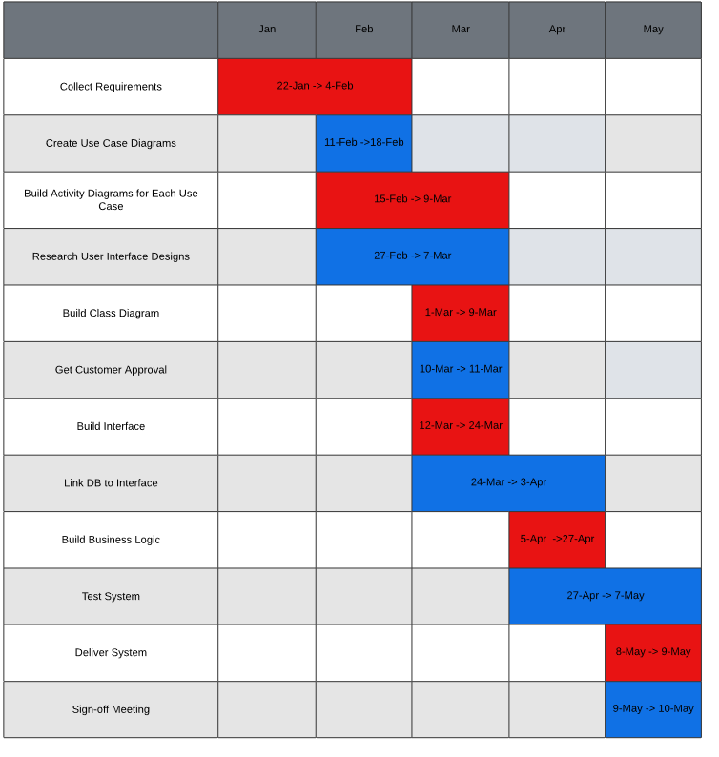

Technical Requirements:

Some of the technical requirements for a system like this are a server to hold the information and back end of the system, and a computer to access the application and communicate between server and user.

UML Use Case Diagram:

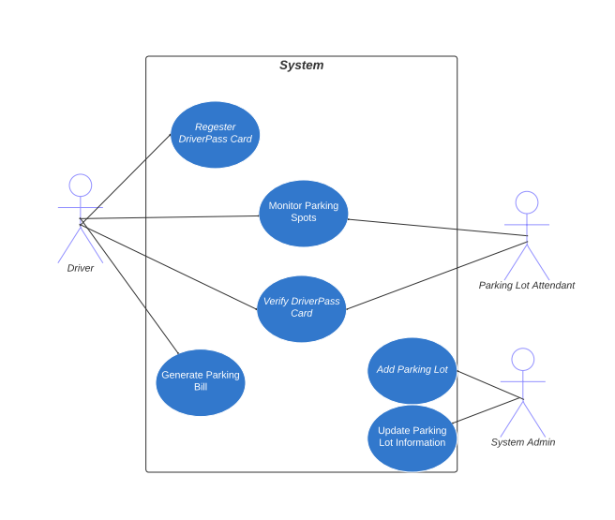

UML Activity Diagrams:

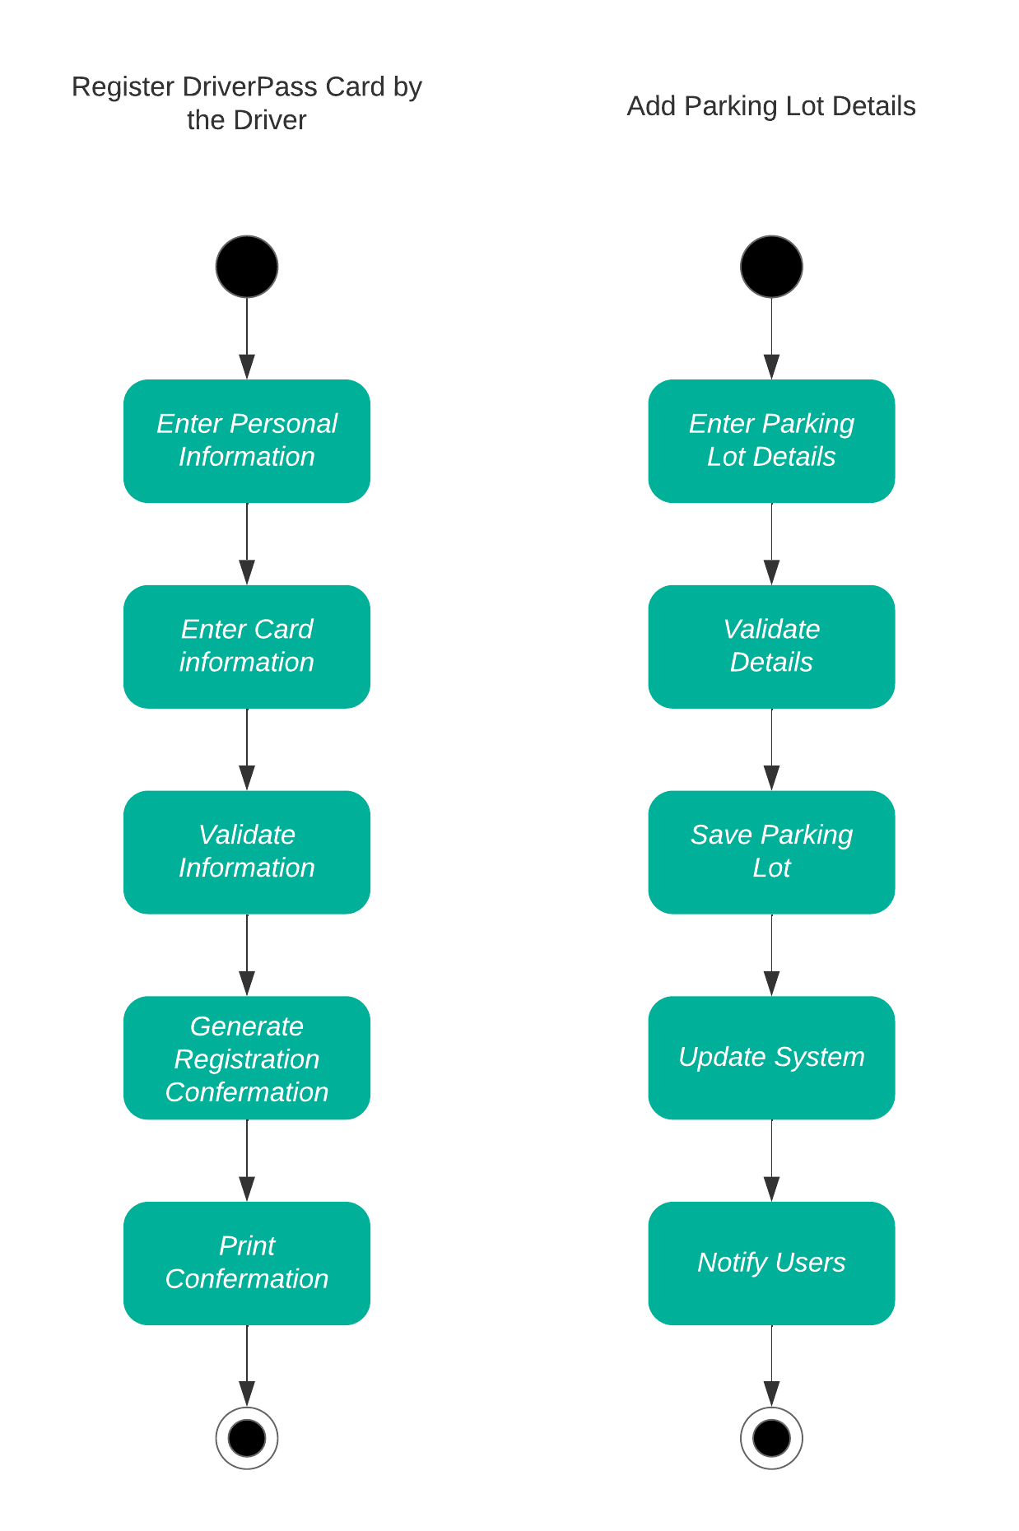

Sequence Diagram:

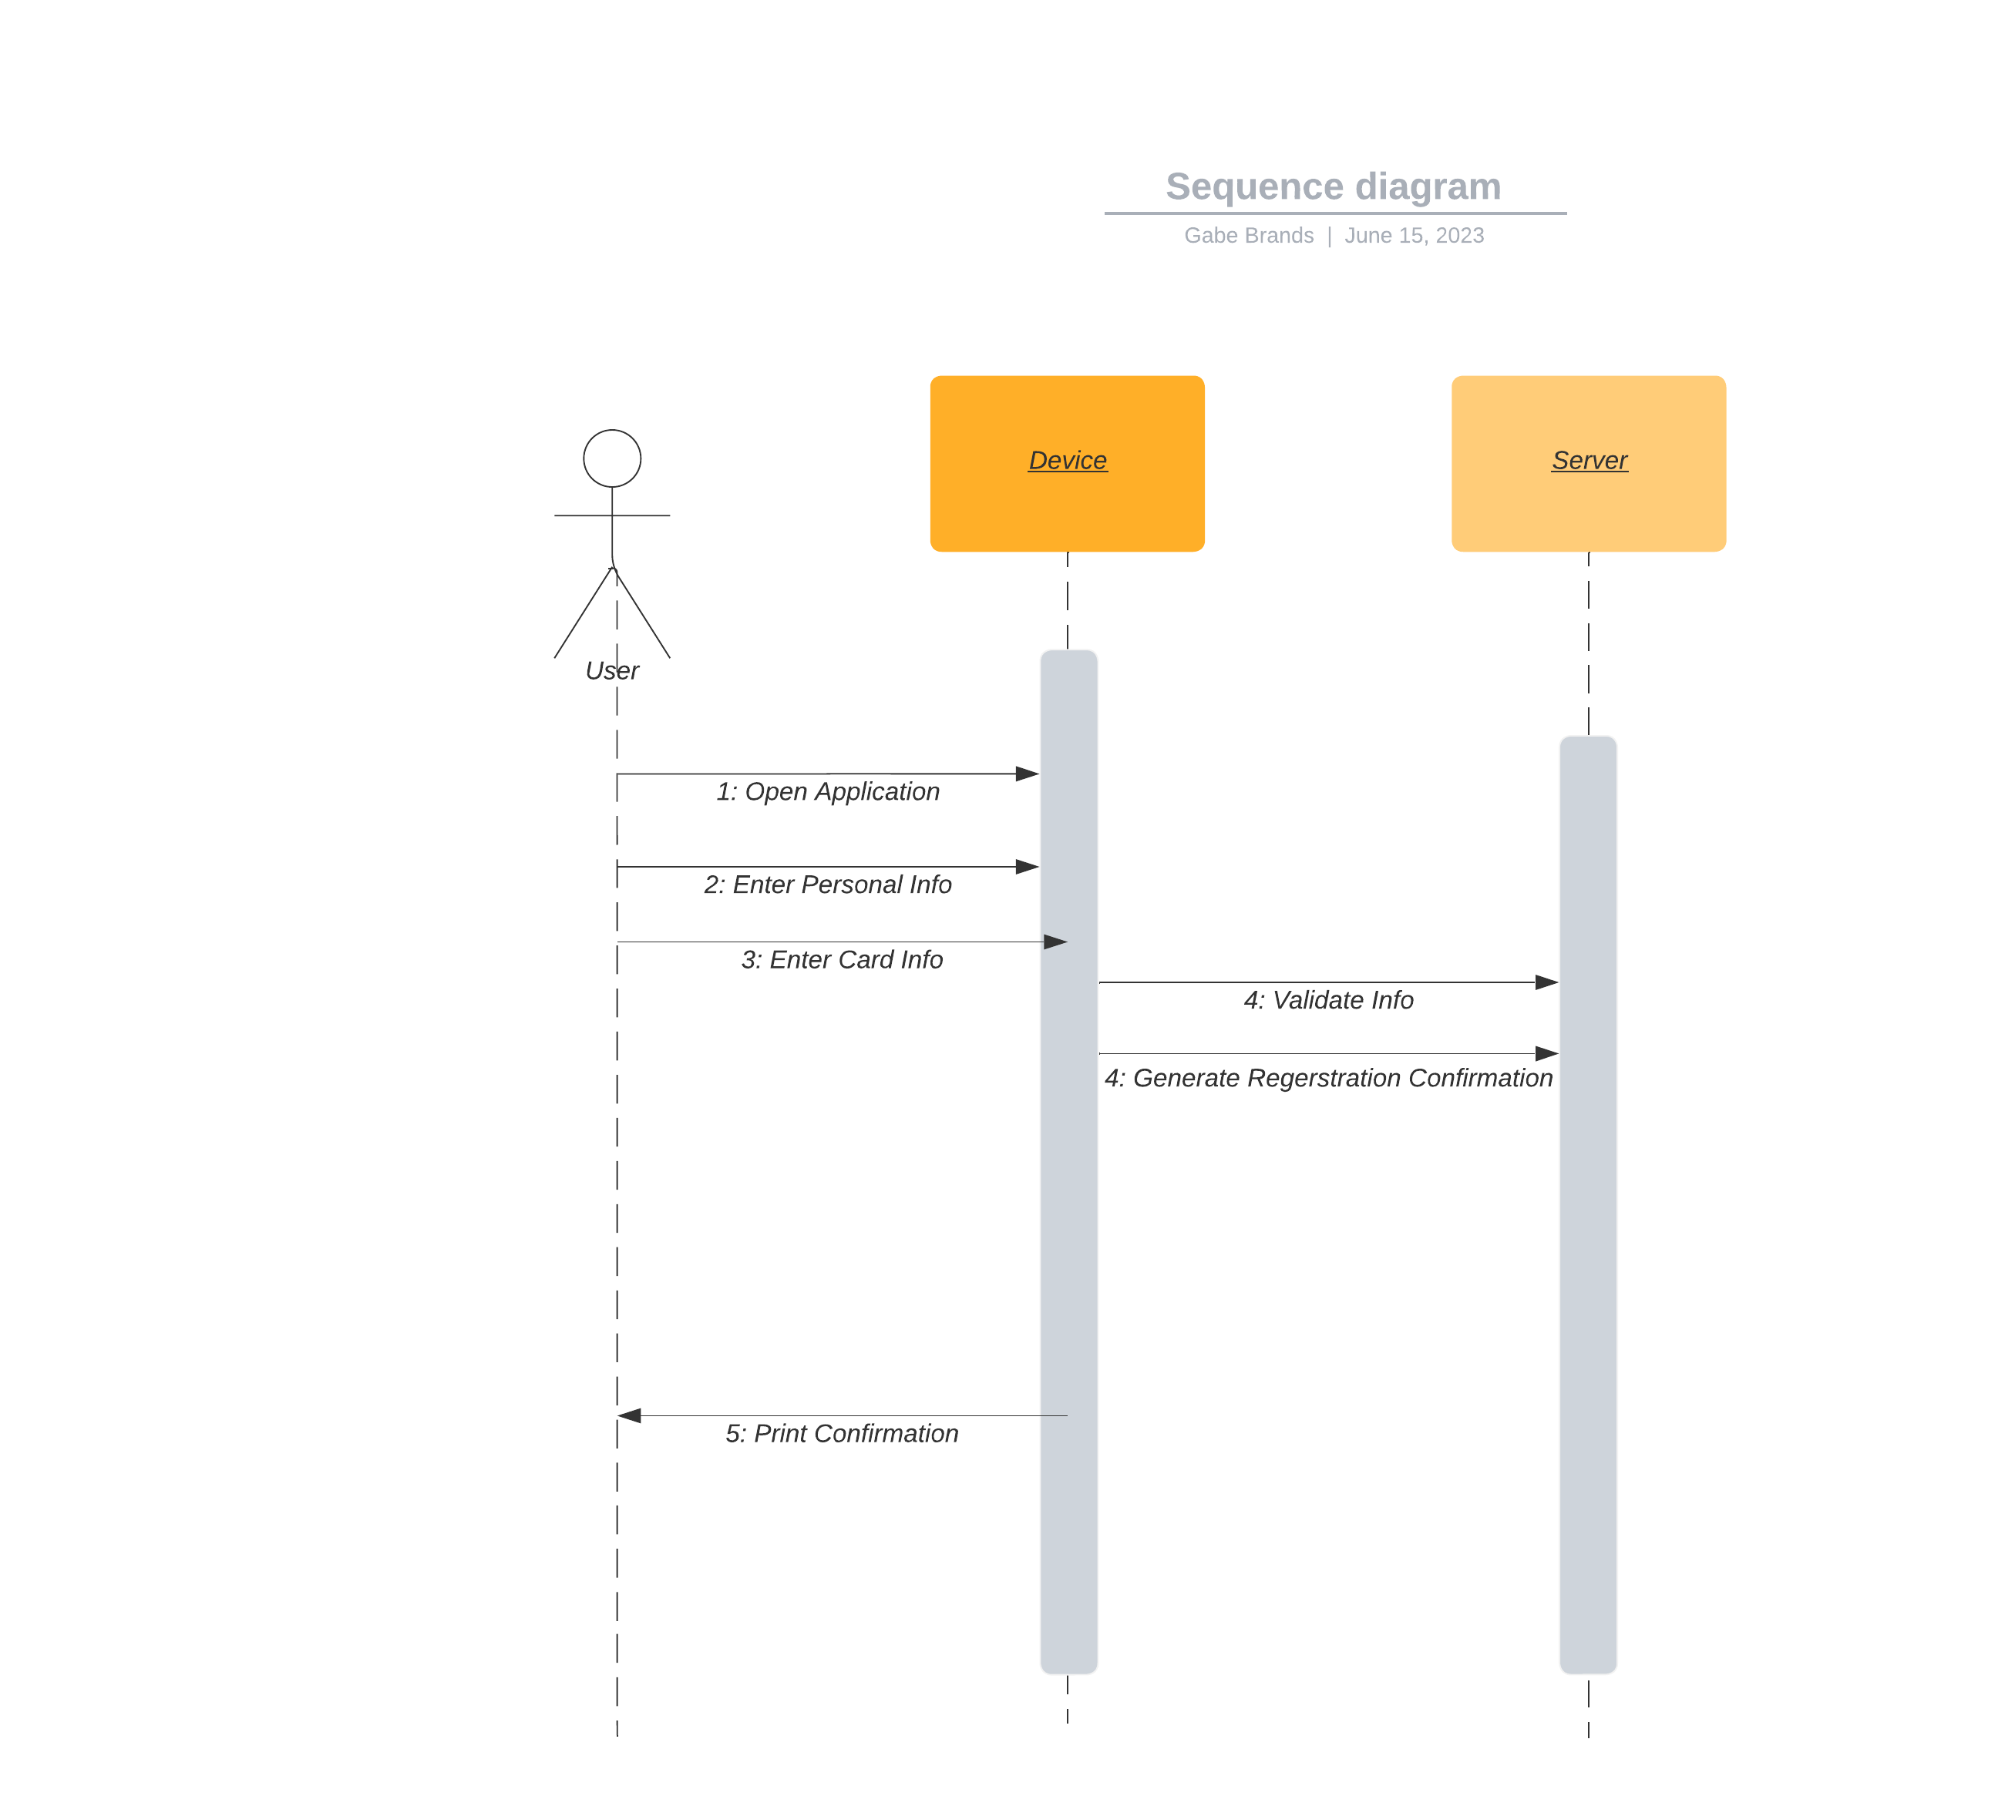

Class Diagram:

